Week 1 | Week 2 | Week 3 | Week 4
Lesson 1 – Who Was Abraham? | Lesson 2 – Who Was Moses? | Lesson 3 – What Is A Moral Code? | Lesson 4 – Jewish Ideas Of God
Key Terms:  Abrahamic: A group of religions who worship the God of Abraham: Judaism, Christianity and Islam.  Monotheism: The belief that there is only one God.  Patriarch: The Father/eldest male.  Covenant: An agreement between God and people.  Sacrifice: Offering something precious to God. | Key Terms:  Prophet: An individual regarded as being in contact with a divine being and is said to speak on behalf of that being.  Miracles: an extraordinary event taken as a sign of the supernatural power of God.  Exodus: The departure of the Israelites from Egypt. | Key Terms:  Moral Code: A set of rules about how people should behave.  Ten Commandments: The ten laws that God gave to Moses and the Israelites on Mount Sinai.  Mitzvot: A commandment commanded by God to be performed as a religious duty. | Key Terms:  Shema: A Jewish prayer that is recited twice daily by Jews to declare their faith.  Creator: A being that brings something into existence.  Judge: God has a right to make laws and to reward people according to whether or not they keep them.
Content:  God made a covenant with Abraham, promising a number of things in return for a loving relationship with Him.  God put Abraham’s faith to the test by asking him to sacrifice his son! He provided a ram instead! | Content:  God made a covenant with Moses and is believed to have talked directly to God.  Moses delivered God’s words and was able to perform miracles sent by God. | Content:  In the Abrahamic religions, Moses is given the Ten Commandments by God as part of the covenant with him. These are a list of 10 rules.  In Judaism, there are 613 commandments (Mitzvot) in the Torah. | Content:  Jewish people believe in One God, Yahweh.  Jews believe God has always and will always exist (eternal).  Jews must love God above all else.  Jews believe that God will judge them.
Questions:  - Who was Abraham?  - What is a covenant?  - How was Abraham’s faith put to the test?  - Why is Abraham so important to Jews, Christians and Muslims? | Questions:  - Who was Moses?  - How did God reveal Himself to Moses?  - What does the story of Moses reveal about God’s nature?  - Why is Moses important? | Questions:  - What is a moral code?  - Are the Ten Commandments important to all three Abrahamic religions?  - What are the Mitzvot? | Questions:  - What is the Shema?  - What can the Shema tell us about the Jewish relationship to God?  - What do Jews believe that God will judge them on?
Week 5 | Week 6 | Week 7 | Week 8
Lesson 5 – Christian Ideas Of God | Lesson 6 – Who Was Jesus? | Lesson 7 – Muslim Ideas Of God | Lesson 8 – Who Was Muhammad?
Key Terms:  Trinity: The Christian belief that God is one but made up of three parts – Father, Son and Holy Spirit.  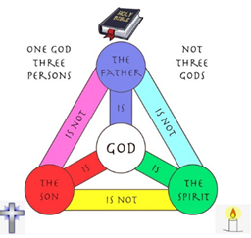 | Key Terms:  Incarnation: The belief that God became human in the form of Jesus.  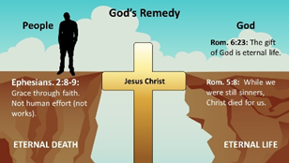  Atonement: The belief that Jesus’ death on the cross healed the rift between humans and God. | Key Terms:  Allah: The Muslim name for God.  Tawhid: Muslim belief in the oneness of Allah.  Shahadah: Declaration of faith that states that Allah is the only God and Muhammad is His messenger.  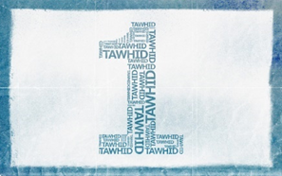 | Key Terms:  Prophet: A person regarded as an inspired teacher or proclaimer of the will of God.​  Revelation: An act of communicating divine truth.  
Content:  Christians believe in the ‘oneness’ of God. There is only one God.  Christians believe that God is one but is made up of three persons:​  God the Father​  The Son: Jesus Christ​  The Holy Spirit ​ | Content:  Christians believe that there are a number of important events in the life of Jesus. Some of these are:  - The Incarnation (God becomes Man)  - The crucifixion and death of Jesus  - The resurrection of Jesus  - Jesus’ ascension to heaven | Content:  Islam teaches that Allah has 99 names.  Images of humans or animals are not allowed in the Islam faith and so these names help Muslims to understand the nature of Allah.  They use words like King, Protector, Wise, Eternal, Light, etc. | Content:  Muhammad was born in 570CE.  Allah revealed the first verses of the Qur’an to Muhammad through the angel Jibril in 610CE, in a cave on Mount Hira.  Muslims believe that God revealed his final message to humankind through Muhammad.
Questions:  - What is the Trinity?  - What are the differences between the Father, Son and Holy Spirit?  - How does belief in the Trinity portray God? | Questions:  - Who was Jesus?  - What events provide evidence that Jesus was divine? | Questions:  - What is Tawhid?  - How does a Muslim show belief in Tawhid in their daily life?  - What is the Shahadah? | Questions:  - What is a prophet?  - How were Allah’s words revealed to Muhammad?  - Why is Muhammad such an important prophet to Muslims?

