Week 1 | Week 2 | Week 3 | Week 4
Lesson 1 – What Is Sikhism? | Lesson 2 – What Do Sikhs Believe? | Lesson 3 – Who Were The Gurus? | Lesson 4 – What Are A Sikh’s 3 Duties?
Key Terms:  Dharmic: Religions which focus on the concept of dharma, which is a sanskrit term for a "law or duty.“  Sikhism: A religion that developed in the 15th century, based on belief in a single god and on the teachings of Guru Nanak.  Guru: Someone who teaches and leads a person to knowledge and understanding of God. | Key Terms:  Guru Granth Sahib: The main holy scripture of Sikhism.  Mool Mantar: The opening section of the Guru Granth Sahib.  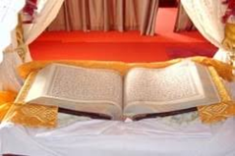 | Key Terms:  Guru: Someone who teaches and leads a person to knowledge and understanding of God.  Langar: The concept of free food for all.  Sewa: 'Selfless service'. It involves acting selflessly and helping others in a variety of ways, without any reward or personal gain. | Key Terms:  Nam Simran: to remember God and meditate on His name.  Kirat karna: to earn one’s living by honest means and hard work.  Vand chhakna: to share with others who are less fortunate.  Samsara: The cycle of birth, death and rebirth.  Mukti: Liberation from samsara.
Content:  Sikhism began in the Punjab region of India and was founded by the first Sikh Guru, Guru Nanak.  Sikhs believe in one God who guides and protects them. They believe everyone is equal before God. | Content:  The Guru Granth Sahib is the Sikh holy book.  The first verse of the Guru Granth Sahib is called the Mool Mantar  It is important as it is the start of the Sikh holy book and also explains the Sikh ideas of God. | Content:  There were 10 Sikh Gurus altogether.  The 3rd Guru, Guru Amar Das introduced the idea of the Langar (free food for all). He also stressed the importance of sewa. | Content:  Guru Nanak gave Sikhs 3 golden rules to follow.  In order to reach mukti, Sikhs must live their life with God in their mind at all times. They must also act with love and compassion.
Questions:  - What is a Dharmic religion?  - What are the main beliefs of Sikhism?  - Who was Guru Nanak?  - Why is Guru Nanak so important to Sikhs? | Questions:  - What is the Guru Granth Sahib?  - What is the Mool Mantar?  - How does the Guru Granth Sahib describe God? | Questions:  - What is a Guru?  - Why are the ten Gurus important to Sikhs?  - What key important ideas or principles did the Gurus introduce? | Questions:  - What are the three golden rules that a Sikh has to follow?  - How do Sikhs put the golden rules into practice?
Week 5 | Week 6 | Week 7
Lesson 5 – The Sikh Path Of Life | Lesson 6 – What Is Amritdhari? | Lesson 7 – Sikh Identity In Britain
Key Terms:  Gurmukh: God centred (Keeping God at the forefront of your mind)  Mukti: Freedom from the cycle of birth, death and rebirth  Samsara: The cycle of birth, death and rebirth  Karma: The consequences of a person’s actions or words | Key Terms:  Amrit: A sanctified solution of sugar and water  Amrit Chhakna: An initiation ceremony into Sikhism  Khalsa Panth: The Sikh community  Shabads: Passages of the Guru Granth Sahib | Key Terms:  Identity: Characteristics that determine who or what a person is.  Turban: A head covering for a man, worn by Sikhs.   | 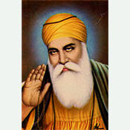
Content:  - In order to reach mukti, Sikhs must live their life with Waheguru (God) in their mind at all times and must rid themselves of all bad karma and focus on gaining good karma.  - They must act with love and compassion towards others. | Content:  - Every Sikh is urged to become an active member of the Khalsa Panth.  - Amrit is sugar crystals dissolved in water by stirring them with the sword while shabads are recited.  - Sikhs who have taken amrit must wear the Five Ks. | Content:  - Most Sikhs settled in Britain in the 1950s and 1960s from the Punjab.  - There are around 500,000 Sikhs living in Britain and over 300 gurdwaras around the country.  - Over 100,000 Sikhs fought in the British Indian Army during World War II. | 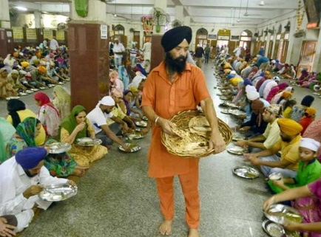
Questions:  - What is Samsara?  - How do Sikhs achieve mukti?  - What does Gurmukh mean?  - What is Karma? | Questions:  - Why are Sikhs urged to become active members of the Khalsa Panth?  - What is Amrit Chhakna and what does it involve?  - What are the 5 K’s? | Questions:  - When and why did the Sikh community in the UK grow?  - Why do Sikh men wear turbans?  - What contributions have Sikhs made to the UK? | 