Week 1 | Week 2 | Week 3 | Week 4
Lesson 1 – What was the Holocaust? | Lesson 2 – Jewish Persecution | Lesson 3 – Anti - Semitism | Lesson 4 – Rise to Power
Key Terms: Holocaust, | Key Terms: Rights, Freedoms, Discrimination | Key Terms: Anti Semitism | Key Terms: Propaganda, dehumanisation
Content:  The Holocaust was the murder of approximately six million Jewish men, women and children by Nazi Germany and its collaborators during the Second World War.​  ​  The Nazis also persecuted people from other minority groups. These groups included Roma (sometimes referred to as ‘Gypsies’), people with disabilities, political opponents, homosexuals, Black people, Jehovah’s Witnesses and others. ​  ​  It is essential to recognise what happened to each of the groups mentioned above. Each of these groups was persecuted for different reasons and in different ways. Some were treated in ways similar to Jewish people, but the reasons for such actions may not have been the same. ​  ​  However, Jewish people “were the only group that the Nazis sought to destroy entirely”. This is why we have the phrase ‘The Holocaust’ to describe what happened to Jewish people during the Second World War. ​ | Content:  Human rights guarantee people the means necessary to satisfy their basic needs, such as food, housing, and education, so they can take full advantage of all opportunities.​  Discrimination is when a person or group of people is treated unfairly compared toothers. Most commonly, discrimination happens because of one's sex, religion, nationality, ethnicity, race, or another personal characteristic.  A freedom is being able to think and say what you want and act how you want(freedom of expression)  By guaranteeing freedom, equality, and security, human rights protect people against prejudice, discrimination, persecution and oppression. | Content:  Anti Semitism is hostility toward, or prejudice and discrimination against, Jews as a religious, ethnic, or racial group, often expressed as hatred, negative stereotypes, and conspiracy theories.  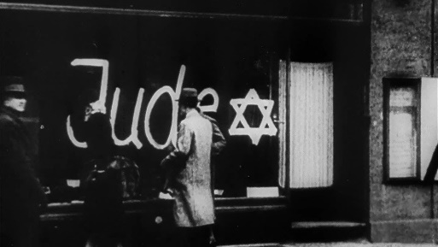  Hitler’s anti semitic views began with prejudice of this group of people which rose to discrimination.  The Nazi’s anti-Semitic views however did begin with Hitler. We can find many extreme examples of Anti-Semitism in over 2000 years of European history. | Content:  Dehumanisation is the process of depriving a person or group of positive human qualities  Propaganda is information or messages that may appear biased or misleading, used to promote a point of view and persuade people to think and behave in a certain way.  The Nazi’s used propaganda to change peoples thinking about them as a party as well as to promote prejudice and discrimination against groups of people – mainly the Jews.  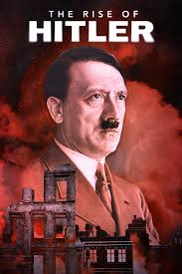
Questions:  What was the Holocaust? | Questions:  What are rights & freedoms  What rights & freedoms do we have? | Questions:  What is Antisemitism?  When did Anti Semitism begin? | Questions:  What is Propaganda?  How did the Nazi’s use propaganda to change peoples thinking?
Week 5 - 6 | Week 7 | Week 8 - 10 | Week 11 - 12
Lesson 5 – Ghetto’s & Resistance | Lesson 6 – A Day in Auschwitz | Lesson 7 – Name to a Number | Lesson 8 – A Boy in the Striped PJ’s
Key Terms: Ghetto, Resistance | Key Terms: Death Camps, Auschwitz, The Final Solution | Key Terms: | Key terms:
Content:  Ghettos were sections of towns and cities where Jewish people were forced to live in overcrowded, unsanitary and inhumane conditions. Life in the ghettos was strictly controlled by the Nazis, with limited food, restricted movement, and widespread disease.  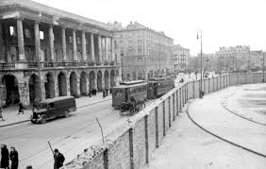  Resistance refers to acts of defiance carried out by Jewish people and others against Nazi oppression.  Resistance could be armed (e.g., the Warsaw Ghetto Uprising) or non‑violent (e.g., smuggling food, continuing education, cultural expression). | Content:  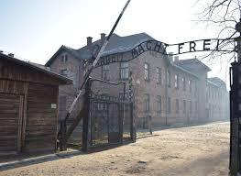  Death camps were facilities built by the Nazis for the mass murder of targeted groups. Auschwitz-Birkenau was the largest Nazi death camp, where more than 1.1 million people were murdered.  The Final Solution was the Nazi plan to systematically exterminate the Jewish population of Europe.  Daily life in Auschwitz was characterised by brutality, starvation, forced labour, overcrowding, and constant fear. | Content:  Prisoners in many Nazi camps were stripped of their names and given numbers to erase their identity and humanity.  Kitty Hart-Moxon survived Auschwitz and spent her life educating others about the Holocaust.  Testimonies like Kitty’s restore humanity to victims by sharing their lived experiences.  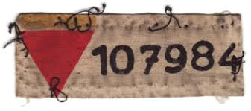 | Content:  ‘The Boy in the Striped Pyjamas’ is a fictional story set during the Holocaust.  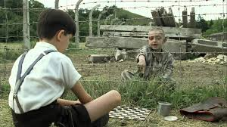  The narrative explores themes of innocence, ignorance, and the impact of prejudice.  Though fictional, the story helps prompt reflection on moral choices and human behaviour.  We watch this film as a way to review out learning over this cycle and reflect on the questions around rights, dehumanisation and anti semitism.
Questions:  What was the purpose of Nazi ghettos?  What forms did Jewish resistance take? | Questions:  What were concentration camps used for?  What was life like for those that lived in the camps? | Questions:  What was the purpose of death camps such as Auschwitz?  How did the Nazis justify the Final Solution? | Questions:  Why is remembering victims' names important when studying the Holocaust?  How does testimony deepen our understanding of the Holocaust?

