Week 1 | Weeks 2 & 3 | Week 4 | Week 5
Lesson 1 – What Is Religion? | Lessons 2 - 3 – Applying The 7 Dimensions | Lesson 4 – Why Do We Have Religion? | Lesson 5 – Using Different Lenses
Key Terms:  Religion: A particular system of faith and worship.  Social: A group of individuals involved in social interaction.  Material: Physical objects, for example, clothes, food, buildings.  Rituals: A religious ceremony consisting of a series of actions. | Key Terms:  Tribe: A social group in society consisting of people with the same language, culture, religion etc.   | Key Terms:  Social Science: The study of human society and social relationships.  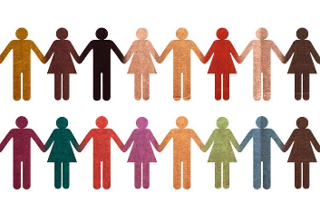 | Key Terms:  Lens: A way of looking at a particular belief or worldview.  Theology: Questions about belief: what it is, where it has come from, how it has changed over time, how it is applied in different contexts  Philosophy: Questions about the nature of reality, existence and knowledge.
Content:  Ninian Smart looked at the features that religions have in common and came up with 7 dimensions:  - Beliefs and teachings  - Rules  - Feelings  - Social  - Material  - Rituals  - Stories | Content:  In order for a tribe to live together harmoniously, different aspects would need to be considered.  Smart’s 7 dimensions from last lesson can be applied to these tribes.  When suffering occurs and tribes are forced to work together, the beliefs of these tribes may conflict. | Content:  Many people need religion for the following reasons:  - It can explain the origins of life.  - Religion can give hope that there is a life after death.  - Most religions contain stories that can offer hope/calm  - Religion can bond communities together  - Religion offers guidance/help | Content:  The 3 core disciplines used in RPE lessons are Theology, Philosophy and the Social Sciences.  We all have our own lenses which will have developed from our life experiences and learning!  Your personal lens may change as you learn and experience more.
Questions:  - What is religion?  - What features do religions have in common?  - What are Ninian Smart’s 7 dimensions? | Questions:  - What is a tribe?  - How can Smart’s dimensions be applied to a tribe?  - What different beliefs might a tribe have? | Questions:  - Why do people need religion?  - What functions does religion contribute to society? | Questions:  - What is a lens?  - What are the 3 core disciplines used in RPE?  - What might influence or change our lens?
Week 6 | Week 7 | Week 8 | Week 9
Lesson 6 – What Is A Worldview? | Lesson 7 – What Is Truth? | Lesson 8 – What Is An Ultimate Question? | Lesson 9 – Science and Religion
Key Terms:  Worldview: A particular philosophy of life or conception of the world.    Influences: To cause someone to change a belief, behaviour or opinion. | Key Terms:  Truth: In accordance with fact or reality.  Belief: An acceptance that something exists or is true, especially one without proof.  Knowledge: Facts, information, and skills acquired through experience or education. | Key Terms:  ‘Ultimate’ Questions: Questions which we may never know the answer to.  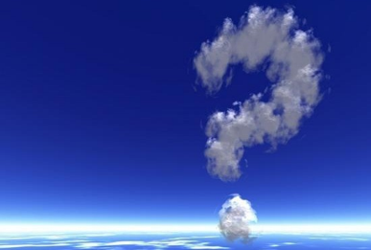 | Key Terms:  Empirical: Based on or verifiable by observation or experience rather than theory.  Evidence: Facts or information indicating whether a belief is true.  Scientific: based on the methods and principles of science.  Creationism: The belief that God created the world.
Content:  Our own worldview journey is personal and will be shaped by our own individual background, family, and cultural influences.  Worldviews differ from person to person. | Content:  - There are different types of truths. Some examples are scientific, moral, spiritual and historical.  - Many people would say for something to be true, there needs to be empirical evidence.  - Some people would argue that beliefs can’t be truths as they don’t always have evidence | Content:  Religious truths try to answer some ultimate questions.  Science and religion often respond in different ways to different situations. For example, when thinking about how the world was created, a scientific approach may be to look at the Big Bang theory or Evolution. | Content:  Many Christians believe in the concept of creationism: that God created the world.  Scientists would approach this idea by looking at evidence – some would come to the conclusion that God did not create the world, but others may look to other evidence, e.g. The Big Bang theory – could God have caused this?
Questions:  - What is a worldview?  - How do worldviews differ from person to person?  - What is your worldview? | Questions:  - What is truth?  - What is the difference between knowledge, belief and truth?  - What different types of truths are there? | Questions:  - What is an ultimate question?  - What is the difference between a religious truth and a scientific truth? | Questions:  - Is life after death a possibility?  - What is the difference between the way a scientist and a religious believer would approach this topic?

