Week 1 | Week 2 | Week 3 | Week 4
Lesson 1 – Does God Exist? | Lesson 2 – How Do We Prove Something? | Lesson 3 – Creation Myths | Lesson 4 – What Is The Design Argument?
Key Terms:  Theist: A person who believes in God  Atheist: A person who disbelieves or lacks belief in the existence of God or gods.  Agnostic: A person who is not sure if God exists or not. | Key Terms:  Proof: Evidence or argument establishing a fact or the truth of a statement.   | Key Terms:  Creation: The action or process of bringing something into existence.  Creationism: The belief that God created the world.  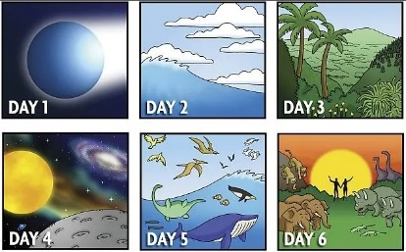 | Key Terms:  Design: A plan or drawing produced to show the look and function or workings of a building or other object before it is made.  Teleological: The explanation of something in terms of the purpose it serves rather than of the cause by which it arises.
Content:  There are different reasons that people give for either believing in God or not. For example, a theist may believe in God because they believe in the idea of the world being created by a powerful being. Yet, an atheist who does not believe in God may say that some creations are dangerous – for example, lightning. | Content:  There are different ways of trying to prove something. Many people say that they need proof to believe in someone’s existence – for example, to see that person or speak to them.  The three main arguments that attempt to prove God’s existence are the Cosmological argument, the Teleological argument and the Ontological argument. | Content:  Many Jews and Christians believe in the concept of creationism: that God created the world according to the story in Genesis.  For many Jews and Christians, the Creation story is one example of proof of how God exists. | Content:  The Design Argument claims that the Universe is too ordered and complicated to have come about by random chance; therefore, it must have been designed. For example, trees take in carbon dioxide and give out oxygen.  William Paley used the Design Argument to explain the existence of God. Things that are designed need a Designer – ie. God!
Questions:  - What is a theist, atheist and agnostic?  - What reasons might someone give for believing in God or not believing in Him? | Questions:  - How do we prove something?  - What different types of evidence have philosophers used to try to prove God exists? | Questions:  - What is Creationism?  - How might a Jew or Christian use the Genesis story of Creation as proof that God exists? | Questions:  - What is the Design Argument?  - How does William Paley use the Design Argument to prove the existence of God?
Week 5 | Week 6 | Week 7 | Week 8
Lesson 5 – Big Bang Theory & Evolution | Lesson 6 – The Cosmological Argument | Lesson 7 – The Moral Argument | Lesson 8 – The Problem of Evil
Key Terms:  Big Bang Theory: How the universe expanded from an initial state of high density and temperature.  Evolution: The process by which different kinds of living organism are believed to have developed from earlier forms during the history of the earth. | Key Terms:  Cause: A person or thing that acts or exists in such a way that some specific thing happens as a result.  Effect: An event, condition, or state of affairs that is produced by a cause.  Cosmological: Relating to the origin and development of the universe. | Key Terms:  Moral: Standards of behaviour; principles of right and wrong.  Lawgiver: A person who draws up, introduces, or enacts a code of laws for a nation or people.  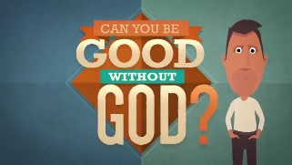 | Key Terms:  Evil: Morally bad and cruel.  Suffering: Undergoing pain, distress or hardship.  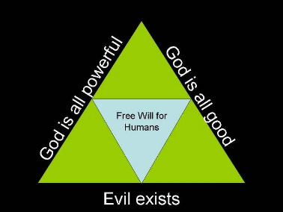
Content:  The Big Bang Theory was proposed in the 1920’s by Alexander Friedman.  There is still evidence today to support the Big Bang Theory as the Universe is still expanding and we can monitor for cosmic radiation.  Charles Darwin proposed that species changed in order to survive (Evolution). | Content:  Everything has a cause and a consequence. If this is the case, there must have been something that caused everything to happen. Thomas Aquinas used this idea to suggest that this First Cause is God which proves that God exists.  A major problem with this theory is that we have no answer to the question, ‘Who caused God?’ | Content:  Immanuel Kant formed the Moral Argument. He argued that humans have a sense of what is right and wrong. Kant’s argument was that there must be someone who made these moral laws: a lawgiver. This lawgiver is God. Therefore, God exists. | Content:  The Greek philosopher, Epicurus claimed that the existence of evil proves that there is no God. He claimed that if God cannot stop evil, then He is not all powerful. He then argued that if God can prevent evil, but does not, then God is not good. If God is all powerful and good, then evil would not exist. Evil does exist, therefore God must not exist!
Questions:  - What is the Big Bang theory?  - What evidence is there to support the Big Bang Theory?  - What is Evolution? | Questions:  - Does everything have a cause?  - Does there have to be a First Cause?  - Could this First Cause be God? | Questions:  - What is the Moral Argument?  - Where do we get our sense of right and wrong from?  - Are there any problems with the Moral Argument? | Questions:  - What is the problem of evil?  - What is the inconsistent triad?  - How is the problem of evil a criticism of the Moral Argument?
Week 9 | Week 10 | Week 11 | Week 12
Lesson 9 – The Ontological Argument | Lesson 10 – Assessment Preparation | Lesson 11 – End of Cycle Assessment | Lesson 12 – Assessment Repair Work
Key Terms:
Ontology: The philosophical study of being.
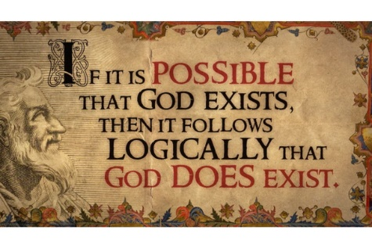
Content:
The philosopher and theologian, Anselm formed the Ontological Argument, stating that the definition of God is ‘The greatest thing that can be thought of.’ It is not possible to think of anything greater than God. Something that exists is better than something that does not exist. Therefore, God exists!
Questions:
- What is the Ontological Argument?
- How can the Ontological Argument prove the existence of God?
- What problems are there with the Ontological Argument?

